**Experiment 2**

**Aim:**

To construct a VLAN and make the PC’s communicate among a VLAN

**Requirements**

• Windows pc – 6 Nos

• CISCO Packet Tracer Software

• 8 port switch – 1 No

• Cat-5 LAN cable

**Procedure**

•Open the CISCO Packet tracer software

• Drag and drop 6 pcs using End Device Icons on the left corner

• Select 8 port switch from switch icon list in the left bottom corner

• Make the connections using Straight through Ethernet cables

• Give IP address of the PCs as per table, ping between PCs and observe the transfer of

data packets in real and simulation mode.

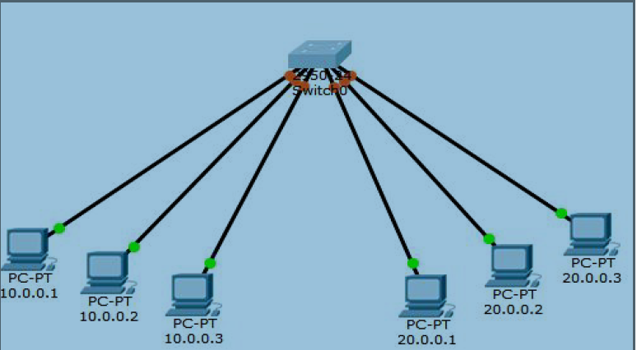

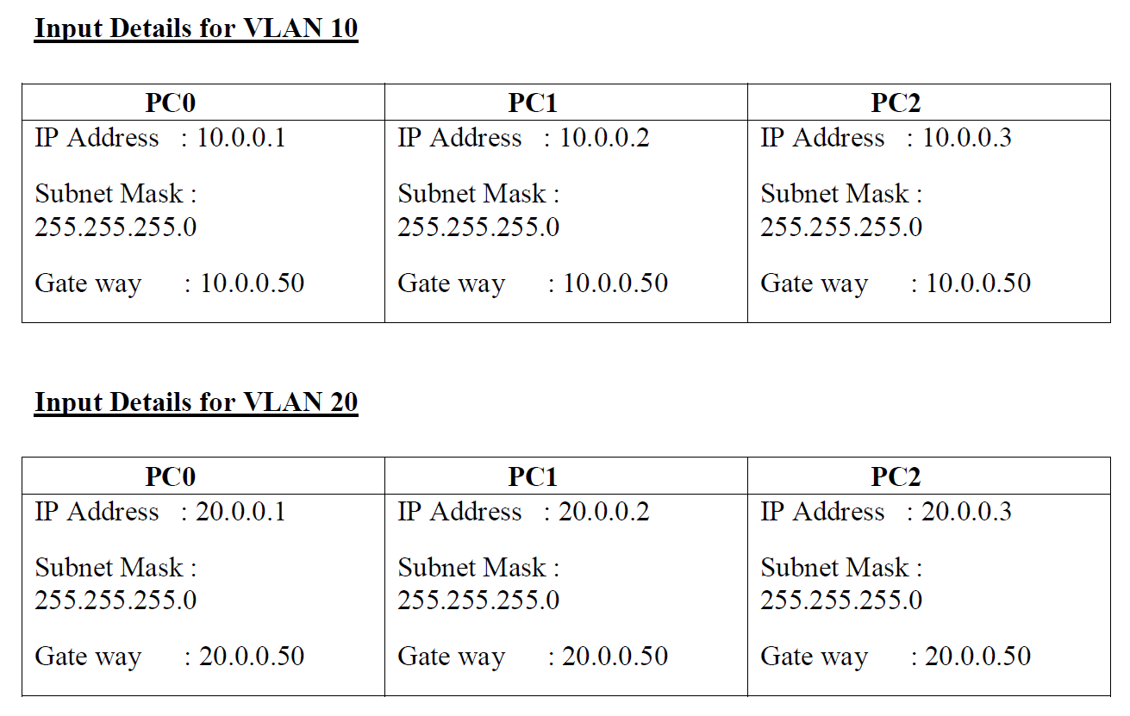

**CONFIGURATION OF THE SWITCHPORT FOR VLAN:**

Switch>en

Switch#config

Configuring from terminal, memory, or network [terminal]?

Enter configuration commands, one per line. End with CNTL/Z.

Switch(config)#vlan 10

Switch(config-vlan)#ex

Switch(config)#vlan 20

Switch(config-vlan)#ex

Switch(config)#interface range fastEthernet 0/1-3

Switch(config-if-range)#switchport access vlan 10

Switch(config-if-range)#ex

Switch(config)#interface range fastEthernet 0/4-6

Switch(config-if-range)#switchport access vlan 20

Switch(config-if-range)#ex

Switch(config)#ex

Switch#

%SYS-5-CONFIG_I: Configured from console by console

**VLAN OUTPUT: (PINGING FROM PC0)**

**C:\>PING 10.0.0.2**

Pinging 10.0.0.2 with 32 bytes of data:

Reply from 10.0.0.2: bytes=32 time=1ms TTL=128

Reply from 10.0.0.2: bytes=32 time<1ms TTL=128

Reply from 10.0.0.2: bytes=32 time<1ms TTL=128

Reply from 10.0.0.2: bytes=32 time<1ms TTL=128

Ping statistics for 10.0.0.2:

Packets: Sent = 4, Received = 4, Lost = 0 (0% loss),

Approximate round trip times in milli-seconds:

Minimum = 0ms, Maximum = 1ms, Average = 0ms

**C:\>PING 20.0.0.1**

Pinging 20.0.0.1 with 32 bytes of data:

Request timed out.

Request timed out.

Request timed out.

Request timed out.

Ping statistics for 20.0.0.1:

Packets: Sent = 4, Received = 0, Lost = 4 (100% loss),

**MAC- ADDRESS TABLE:**

**Result**

